DSA 0601 - Data handling and visualization
Set 15 - Product Sales Analysis

- Grouped Bar Chart for First-Quarter Sales
Code:

library(ggplot2)
library(tidyr)

# Create dataset
sales <- data.frame(
Product_ID = c(1, 2, 3),
Product_Name = c("Product A", "Product B", "Product C"),
January = c(2000, 1500, 1200),
February = c(2200, 1800, 1400),
March = c(2400, 1600, 1100)
)

# Convert data to long format
sales_long <- pivot_longer(
sales,
cols = c(January, February, March),
names_to = "Month",
values_to = "Sales"
)

# Create grouped bar chart
ggplot(sales_long, aes(
x = Product_Name,
y = Sales,
fill = Month
)) +
geom_bar(stat = "identity", position = "dodge") +
labs(
title = "First-Quarter Sales by Product",
x = "Product Name",
y = "Sales",
fill = "Month"
) +
theme_minimal()

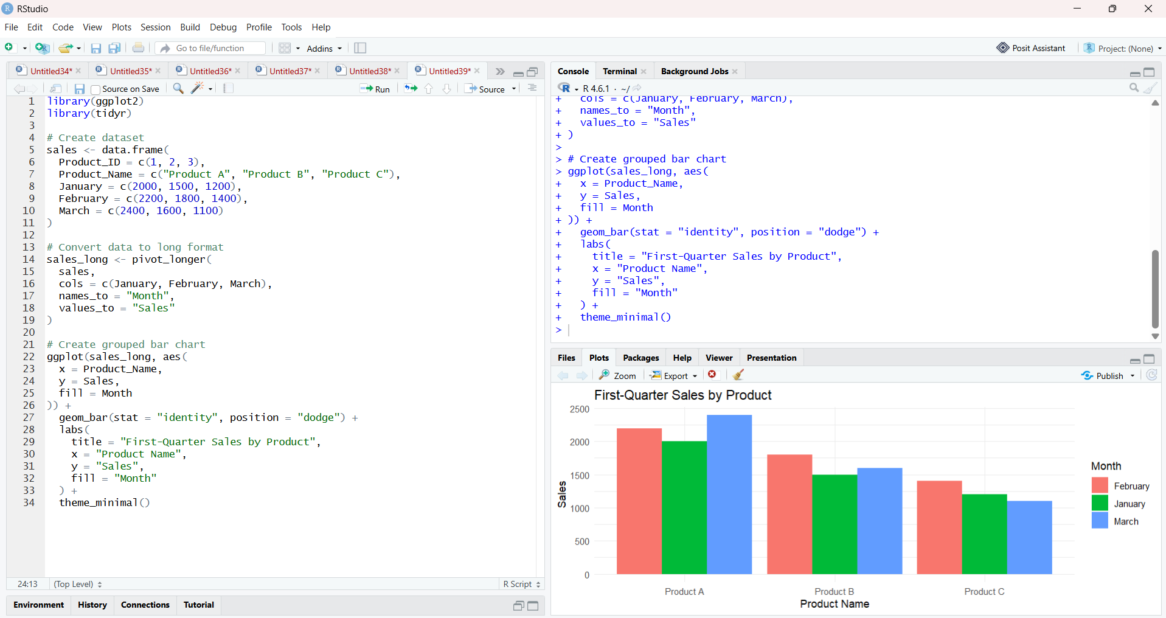

- Stacked Area Chart for Overall Sales Trend
Code:

library(ggplot2)
library(tidyr)

# Create dataset
sales <- data.frame(
Product_Name = c("Product A", "Product B", "Product C"),
January = c(2000, 1500, 1200),
February = c(2200, 1800, 1400),
March = c(2400, 1600, 1100)
)

# Convert data to long format
sales_long <- pivot_longer(
sales,
cols = c(January, February, March),
names_to = "Month",
values_to = "Sales"
)

# Arrange months in correct order
sales_long$Month <- factor(
sales_long$Month,
levels = c("January", "February", "March")
)

# Create stacked area chart
ggplot(sales_long, aes(
x = Month,
y = Sales,
fill = Product_Name,
group = Product_Name
)) +
geom_area() +
labs(
title = "Overall Monthly Sales Trend",
x = "Month",
y = "Sales",
fill = "Product"
) +
theme_minimal()

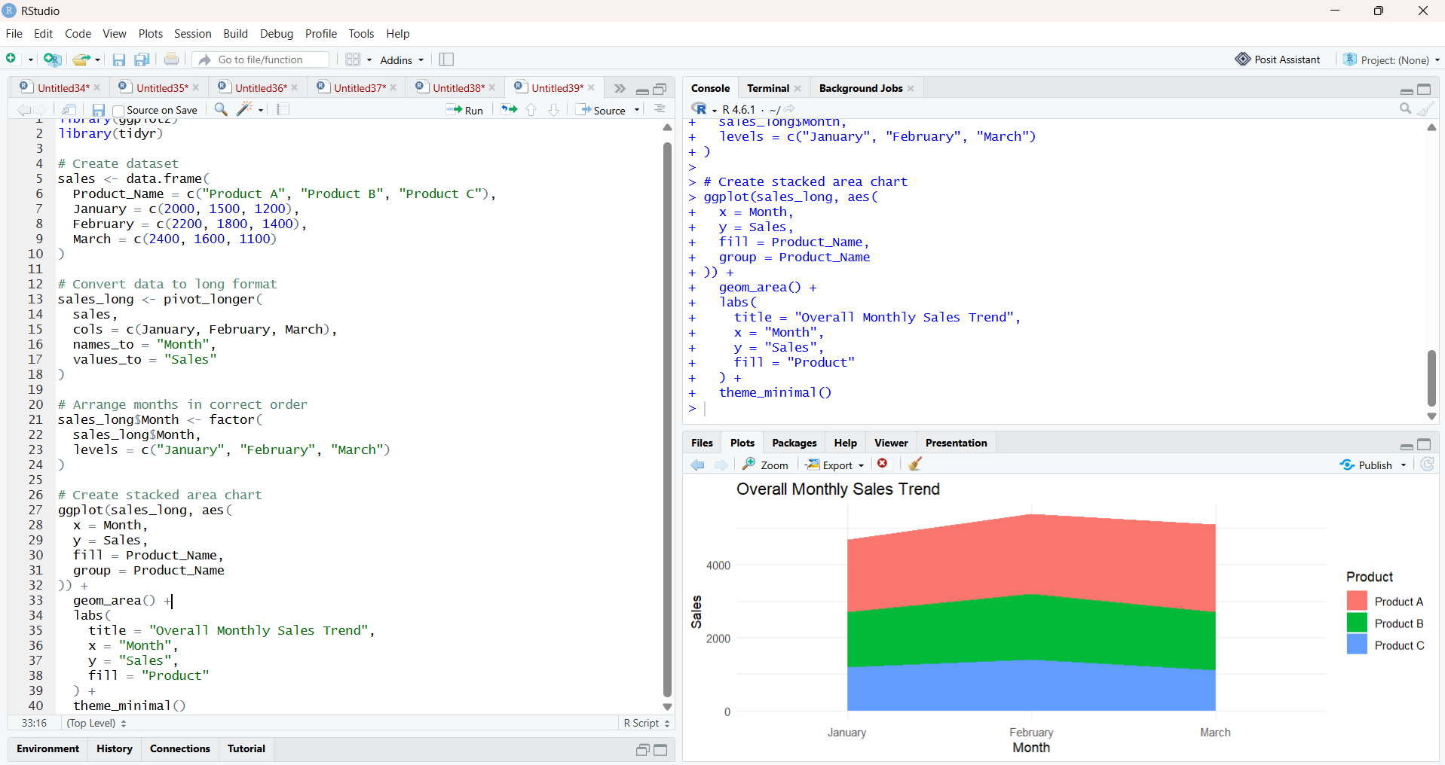

- Table of Monthly Sales Data
Code:

# Create dataset
sales <- data.frame(
Product_ID = c(1, 2, 3),
Product_Name = c("Product A", "Product B", "Product C"),
January = c(2000, 1500, 1200),
February = c(2200, 1800, 1400),
March = c(2400, 1600, 1100)
)

# Display table
print(sales)

# Optional formatted table
library(knitr)

kable(
sales,
caption = "Monthly Product Sales for the First Quarter",
col.names = c(
"Product ID",
"Product Name",
"January Sales",
"February Sales",
"March Sales"
)
)

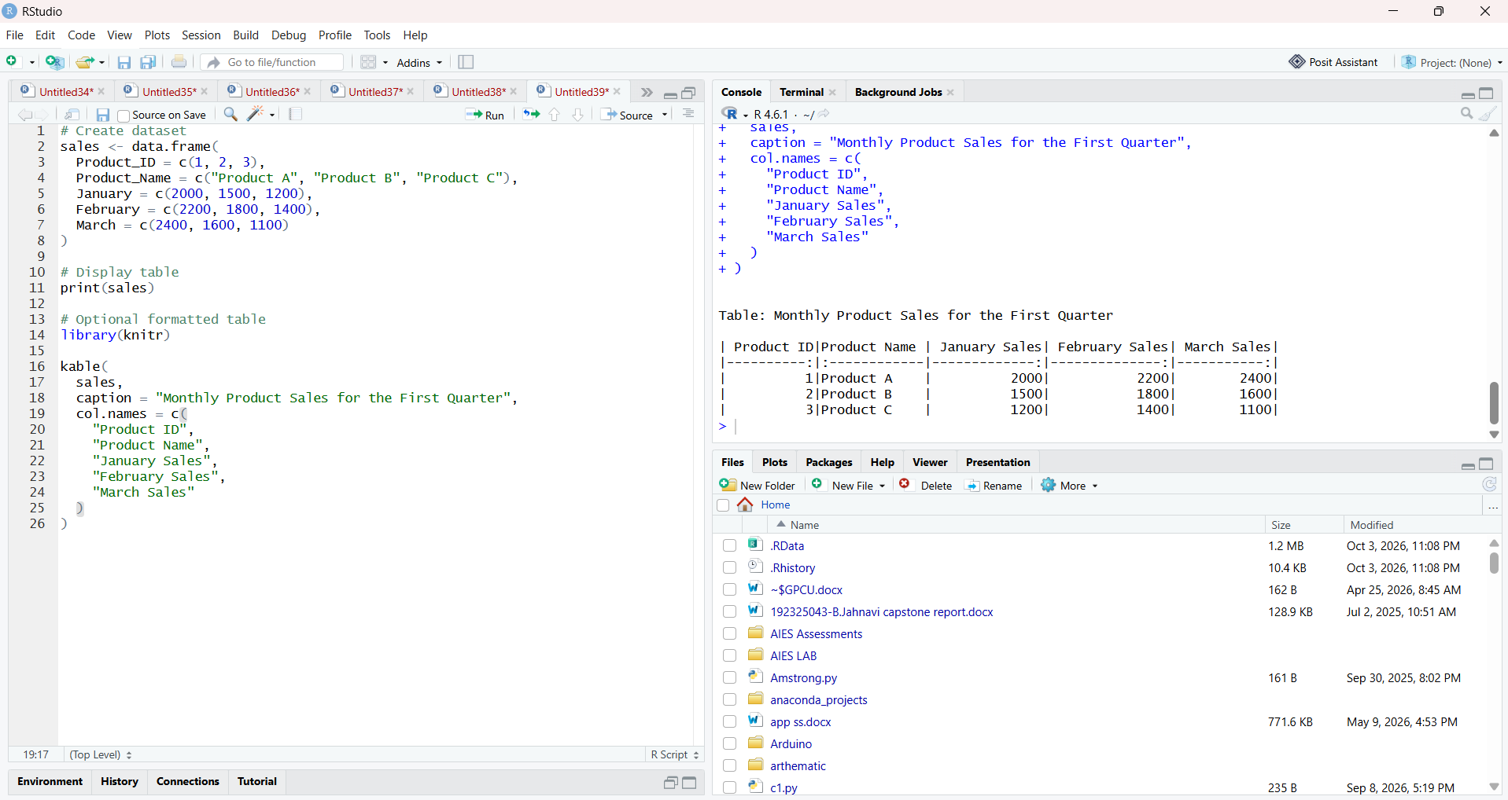

- Prepare Data for a Tableau Dashboard
Code:

# Create dataset
sales <- data.frame(
Product_ID = c(1, 2, 3),
Product_Name = c("Product A", "Product B", "Product C"),
January = c(2000, 1500, 1200),
February = c(2200, 1800, 1400),
March = c(2400, 1600, 1100)
)

# Export dataset
write.csv(
sales,
"monthly_product_sales.csv",
row.names = FALSE
)

print("CSV file created successfully.")

